Petri Nets
# Source: AI Source: Provided by: [Data Path: Persons Table -> ID Column: 1, Name_En Column: Motasem Essam] -> From: [ChatGPT] on [1/21/2026]
Petri Nets are a powerful modeling technique in Real-Time Systems (RTS) used to describe concurrent, asynchronous, and distributed systems. They help in analyzing task execution, synchronization, and resource conflicts.

Definition
# Source: AI Source: Provided by: [Data Path: Persons Table -> ID Column: 1, Name_En Column: Motasem Essam] -> From: [ChatGPT] on [1/21/2026]
A Petri Net is a graphical and mathematical modeling tool that represents:
- States (Places) – conditions or resources
- Events (Transitions) – tasks or activities that change the state
- Tokens – represent the presence of a resource or task readiness
- Arcs – connect places and transitions, showing how tokens move
Petri Nets are particularly useful for modeling concurrency, synchronization, and resource sharing in real-time systems.

Key Components
# Source: AI Source: Provided by: [Data Path: Persons Table -> ID Column: 1, Name_En Column: Motasem Essam] -> From: [ChatGPT] on [1/21/2026]
- Places (circles)
  - Represent conditions, states, or resources.
- Transitions (rectangles or bars)
  - Represent events or tasks that change the state.
- Tokens (dots inside places)
  - Represent availability of a resource or readiness of a task.
- Arcs (arrows)
  - Connect places and transitions; define preconditions and postconditions.

How It Works
# Source: AI Source: Provided by: [Data Path: Persons Table -> ID Column: 1, Name_En Column: Motasem Essam] -> From: [ChatGPT] on [1/21/2026]
- A transition is enabled if all its input places have the required tokens.
- When the transition fires, it consumes tokens from input places and produces tokens in output places.
- This models task execution, resource usage, and synchronization.

Example
# Source: AI Source: Provided by: [Data Path: Persons Table -> ID Column: 1, Name_En Column: Motasem Essam] -> From: [ChatGPT] on [1/21/2026]
A simple RTS task sequence:
- Task A requires Resource R1, then triggers Task B.
Petri Net Representation:
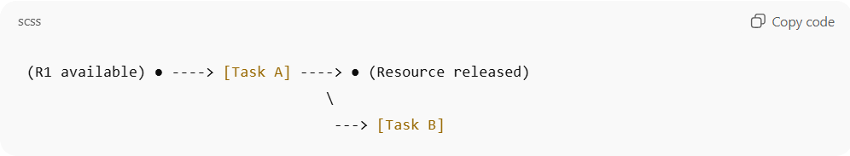
(R1 available) ● ----> [Task A] ----> ● (Resource released)
\
---> [Task B]
- Token in R1 allows Task A to execute.
- After Task A fires, token moves, enabling Task B.

Advantages
# Source: AI Source: Provided by: [Data Path: Persons Table -> ID Column: 1, Name_En Column: Motasem Essam] -> From: [ChatGPT] on [1/21/2026]
- Models concurrent and asynchronous tasks naturally
- Captures synchronization and resource conflicts
- Can be analyzed mathematically for deadlocks, reachability, and liveness
- Supports both graphical and formal modeling

Disadvantages
# Source: AI Source: Provided by: [Data Path: Persons Table -> ID Column: 1, Name_En Column: Motasem Essam] -> From: [ChatGPT] on [1/21/2026]
- Can become complex for large systems
- Requires understanding of token flow and formal analysis

Applications
# Source: AI Source: Provided by: [Data Path: Persons Table -> ID Column: 1, Name_En Column: Motasem Essam] -> From: [ChatGPT] on [1/21/2026]
- Modeling real-time task scheduling
- Communication protocols
- Workflow and process synchronization
- Embedded systems and industrial automation
- Deadlock detection and resource allocation analysis

